Volkswagen Settlement Indian Tribe Trust Program Semi-Annual Report
Red Lake Band of Chippewa Indians

This report is hereby presented to Wilmington Trust, as Trustee for the Volkswagen Diesel Emissions Environmental Mitigation Trust for Indian Tribe Beneficiaries (“the Tribal Trust”). The Beneficiary named below submits this report in compliance with the semiannual reporting requirements described in Section 5.3 of the Modified Trust Agreement, for the six-month period specified below.

Beneficiary Name: Red Lake Band of Chippewa Indians
Funding Cycle: Third Funding Cycle
Six-Month Period: 1\31\2021 – 7\30\2021 (Final Report)
Lead Agency: Red Lake DNR Environmental Program
Lead Agency Contact: Jennifer Malinski
Summary of all Financial Costs (expended through Reporting Date):
Funding Source | Amount | Description
VW Settlement Funds | $322,443 | Purchase of Vacuum Truck, Refuse Truck, and Salary
Tribal Funds | NA | NA
EPA DERA Funds | NA | NA

Beneficiary Reporting Obligations (per Section 5.3 of the Indian Tribe Trust)
Description of Status (include actual or projected termination date):
This Round 3 Project will deploy two new diesel vehicles: a septic truck under Section 6(e)(2) of Appendix D-2 to the Indian Tribe Trust Agreement and a semi truck under Section 1(f)(2) of Appendix D-2 of the Indian Tribe Trust Agreement. Both new trucks will operate out of Red Lake but service the surrounding communities of Little Rock, Redby, and Ponemah as well.
The eligible vehicles being replaced include a 1993 Freightliner Conv. Cab Septic Truck, VIN 1FV6HFBA1PL447171, and a 1994 Ford LT9000 Semi Truck, VIN 1FDYU90XXRVA05226. The new septic truck arrived in Red Lake on January 27, 2021. The new semi truck arrived in Red Lake on April 30, 2021.
Far North Auto of Bemidji, MN was selected for decommissioning the trucks being replaced. The replaced trucks were rendered inoperable (meaning, at a minimum, they will have a 3-inch hole cut in the engine block and their frame rails will be cut completely in half) and made available to recycle during this reporting period. The 1993 Freightliner Conv. Cab Septic Truck was disabled on 3/16/2021 and the 1994 Ford LT9000 Semi Truck was disabled on 5/26/2021.
This Round 3 Project also includes admin costs that were incurred during this reporting period.
The project schedule and budget have had revisions as detailed below. Costs expended are also detailed below.

Development (planning work accomplished for the project):
Milestones | Original Date | Revised Date | Explanation
Lead Agency issues request for quotes to vendors for acquisition of low-emission new diesel Class 7 truck and Class 8 truck | 7/31/2020 |  | Completed on schedule
Lead Agency provides project certification and funding direction to Trustee | 8/28/2020 |  | Completed on schedule
Trustee allocates share of funds for approved project | 11/12/2020 | 10/30/2020 | Funds allocated ahead of schedule
Lead Agency directs funding and enters into contracts for acquisition of low-emission new diesel trucks | 1/15/2021 |  | Completed on schedule
Low-emission new diesel trucks in use | 4/15/2021 | 4/30/2021 | New septic truck in use 1/27/2021  New semi truck in use 4/30/2021
Eligible trucks decommissioned and scrapped | 6/15/2021 |  | Completed on schedule
Lead Agency provides detailed invoices for all claimed project costs, documentation for emission reduction estimates, required certification documents to Trustee for final accounting* | 7/30/2021 |  | Completed on schedule
Lead Agency reports project completion | 7/30/2021 |  | Completed on schedule
*Provided upon request

Implementation (purchases, construction/installation of infrastructure, etc.):
Figure 1. Certificate of Engine/Chassis destruction for 1993 Freightliner septic truck.

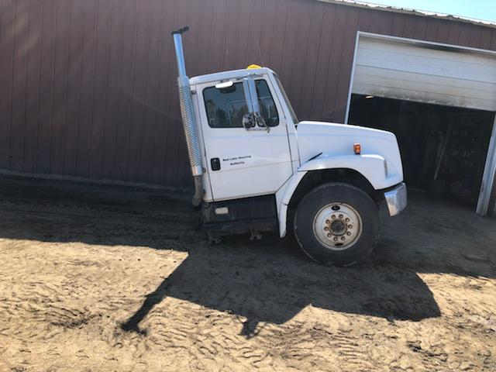
Figure 2. Frame of 1993 Freightliner cut in half.
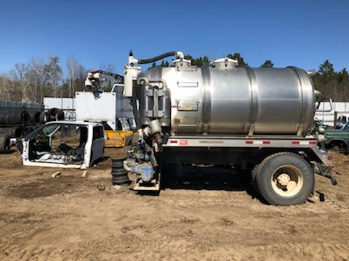
Figure 3. Frame of 1993 Freightliner cut in half.

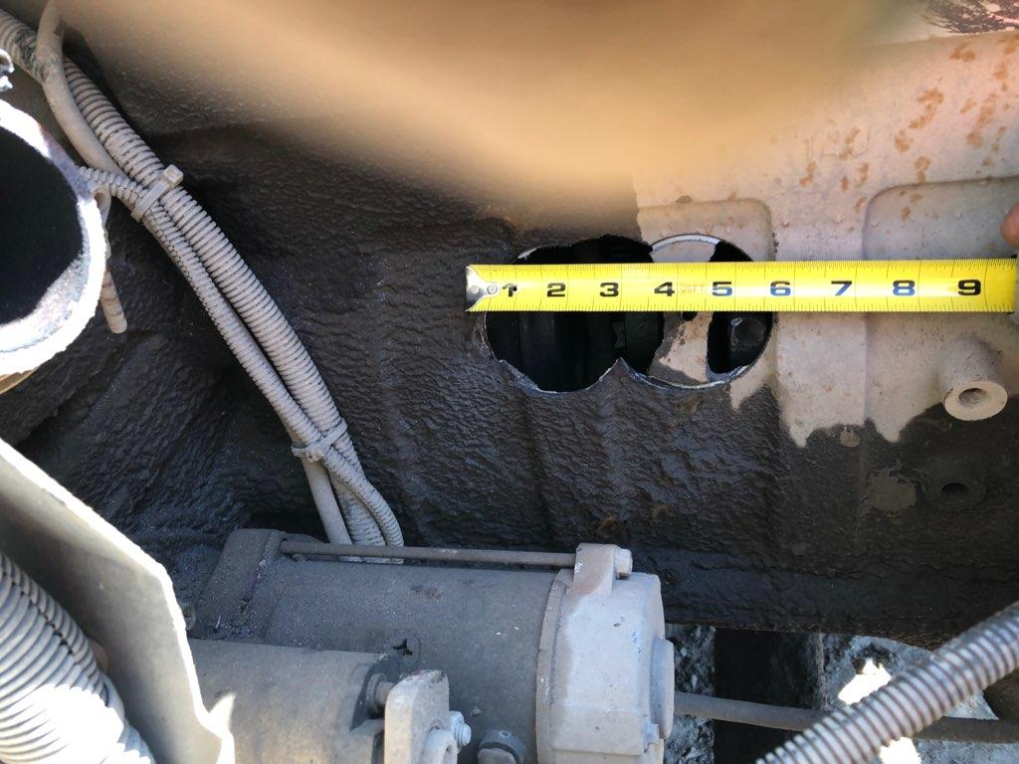
Figure 4. Hole drilled in 1993 Freightliner engine block.
Figure 5. Certificate of Engine/Chassis destruction for 1994 Ford semi truck.

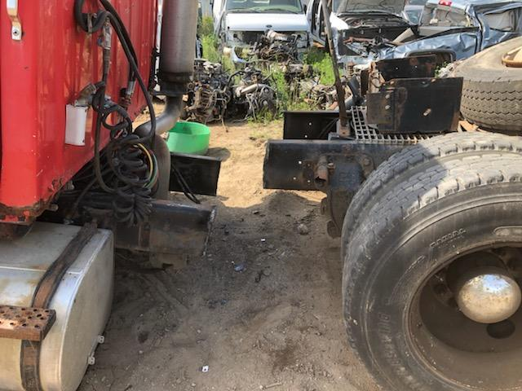
Figure 6. Frame of 1994 Ford cut in half.
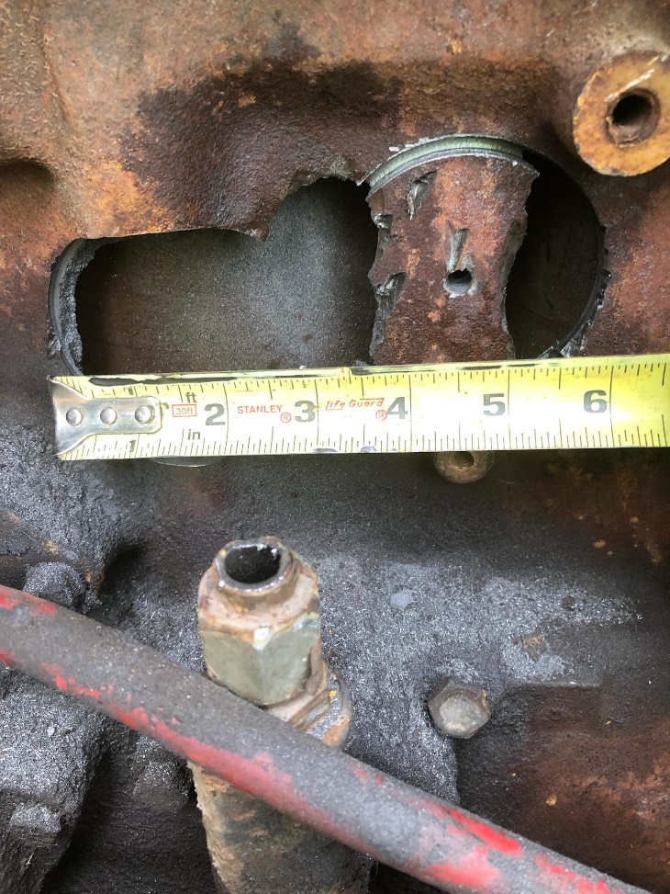
Figure 7. Hole drilled in 1994 Ford engine block.

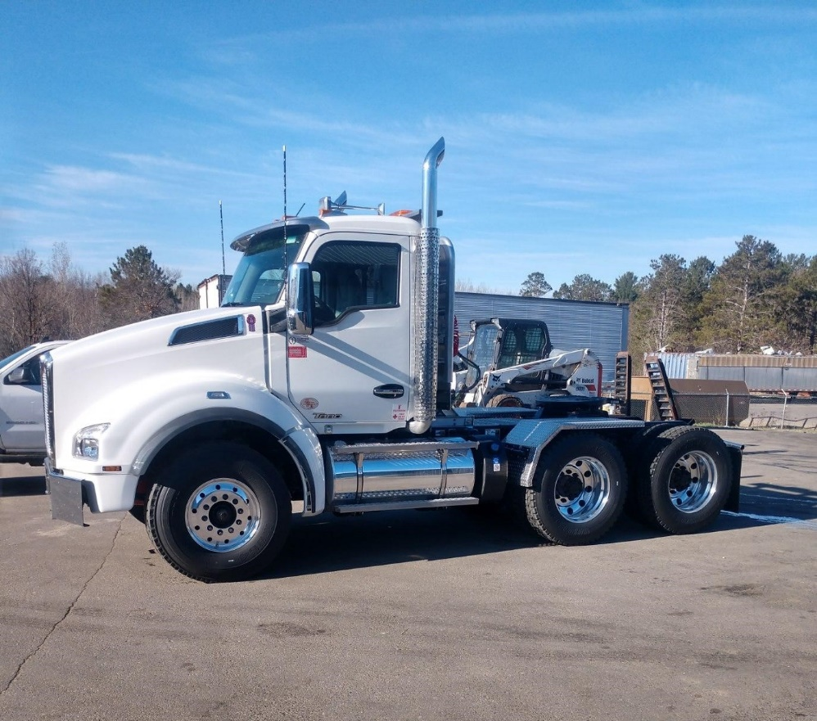
Figure 5. New Semi truck arrived in Red Lake on 4/30/2021.
Any modification to each approved Eligible Mitigation Action (including changes to equipment costs, tribal cost share, etc.):
Total Project Budget:
Eligible Mitigation Action and Mitigation Action Expenditure Categories | Item | Cost | Qty. | Revised Budget | Original Budget
D-2 Section 6(e)(2) - Government Owned Medium Trucks | Septic Truck | $158,714.50 | 1 | $158,714.50 | $162,499.00
D-2 Section 1(f)(2) - Government Owned Class 8 Large Trucks | Semi Truck | $156,275.00 | 1 | $156,275.00 | $152,782.00
Admin Costs | Salary | $7,453.50 | 1 | $7,453.50 | $7,162
Project Total |  |  |  | $322,443.00 | $322,443.00
I, Jennifer Malinski, attest that the information provided in this report is true and correct and that the submittal of this report is made under penalty of perjury.
This report has been submitted to the Trustee on this day, June 30, 2021, via the Intralinks online file sharing platform.
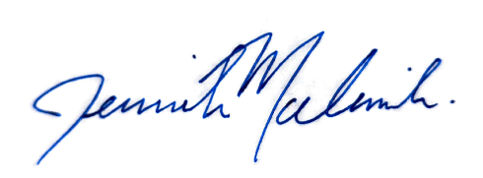

Signature:

